**Information System Management Lab**

**BCOM 307**

**Assignment #5**

***Submitted by:***

**Name:** YASH JAIN

**Enrollment No:** 03914788818

**Semester:** B.Com(H) 5th Semester

**Class:** B.COM(H)

**Section:** B.Com 5A

**Date of Submission:** 25/09/2021

***Submitted to:***

**Praveen Kumar Singh**

**Assistant Professor, MAIMS**



**Department of Commerce**

**Maharaja Agrasen Institute of Management Studies**

**Affiliated to Guru Gobind Singh Indraprastha University, Delhi**

**Sector -22, Rohini, Delhi -110086, India; www.maims.ac.in**

Maharaja Agrasen Institute of Management Studies

Affiliated to GGS IP University; Recognized u/s 2(f) of UGC Recognized by Bar Council ofIndia; ISO 9001: 2015

Certified Institution Sector 22, Rohini, Delhi -110086, India; [www.maims.ac.in](http://www.maims.ac.in/)

Department of Commerce

Academic Year: 2020-21

Semester: Vth

# Assignment No.5

# Unit No:

**Course/Subject Code:** BCOM 307 **Subject Title: Information System Management Lab**

# Issue Date: Last Date of Submission:

**Instructions for Students:**

# All Questions are Compulsory.

1. The student should attach proper cover page for each assignment clearly mentioning the Assignment No.
2. Each assignment should be prepared by the student individually with proper explaination and screenshots.
3. A4 size ruled sheets should be used for the assignment.
4. Assignment pages should be serially numbered at the bottom of page.

***During online education mode, upload scanned copy of the complete assignment including cover page latest by due date.***

|  |  |  |
| --- | --- | --- |
| **Question No.** | **Question** | **CO No.** |
| 1 | Create a table ‘Student’ with the following columns :-   * Enrollment No (Primary key) * Name * Email ID * Address * Mobile * Date of Birth * Marks | **CO1** |
| 2 | Insert 3 records in the ‘student’ table, with distinct values of enrollment number. |
| 3 | Insert another record, where enrollment number is same as any one of the 3 records inserted, and all other values different. |
| 4 | Insert another record, this time keeping enrollment number different, and all the other values same as any of the records inserted in the table. |

**ASSIGNMENT 5 - PRIMARY KEY CONSTRAINT**

**Task 1 : Create a table ‘Student’ with the following columns :-**

1. **Enrollment No (Primary key)**
2. **Name**
3. **Email ID**
4. **Address**
5. **Mobile**
6. **Date of Birth**
7. **Marks**

The following task is completed using the **‘create table’** command, along with the **‘primary key constraint’**. Primary Key is one or more columns that uniquely identifies each row in the table. It means that each row value in this column would be distinct; there won't be any duplicate values. The syntax for primary key (to be used in table definition) is:

column_name datatype primary key,

(rest of the table definition)

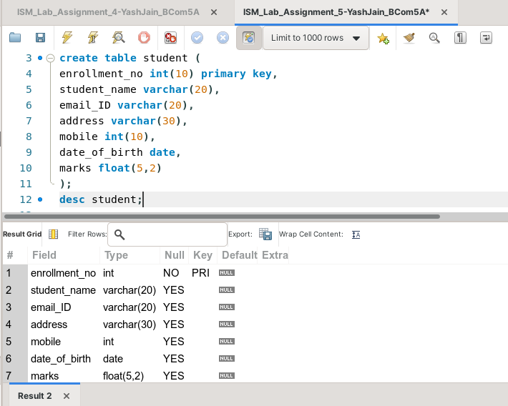

**Task 2: Insert 3 records in the ‘student’ table, with distinct values of enrollment number.**

The given task can be completed using the **‘insert into’** command. Note that when you will enter values, you cannot enter duplicate values in the primary key column, as it will show an error.

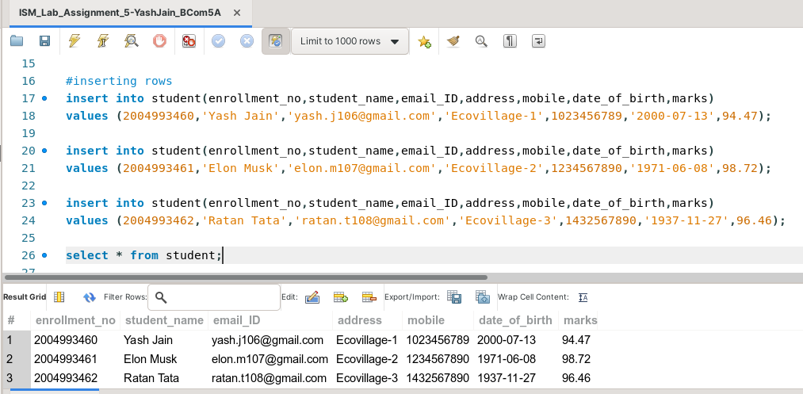

**Task 3: Insert another record, where enrollment number is same as any one of the 3 records inserted, and all other values different.**

This task can be completed by using the command **‘insert into’.** Here, one will observe that **this query won’t be completed**. This is because enrollment number is a primary key, hence we cannot enter duplicate values for it.

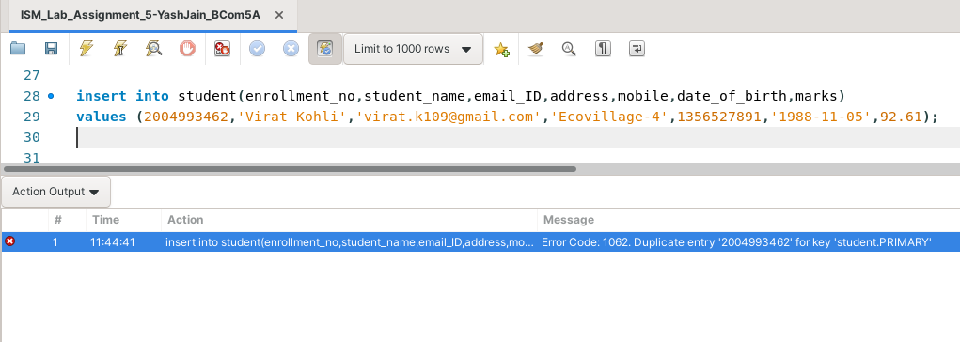

**Task 4: Insert another record, this time keeping enrollment number different, and all the other values same as any of the records inserted in the table.**

This task can be completed using the **‘insert into’** command. One would observe that this query will be completed, since the enrollment number is unique (required as per primary key constraint), but the other columns are not primary keys, hence their values can repeat.

